Annex 10: Stakeholder Engagement Plan
The Stakeholder Engagement Plan is designed to ensure effective engagement between various stakeholders throughout the lifecycle of the project. This plan will build on any other work which is being undertaken with regard to planning and impact assessment processes. The project will aim to maintain dialogue with the relevant government ministries and parastatals, selected local community groups, NGOs and international community.
1. Structure of Government
Fig. 1 – Composition of the XVII Government of Sao Tomé and Principe
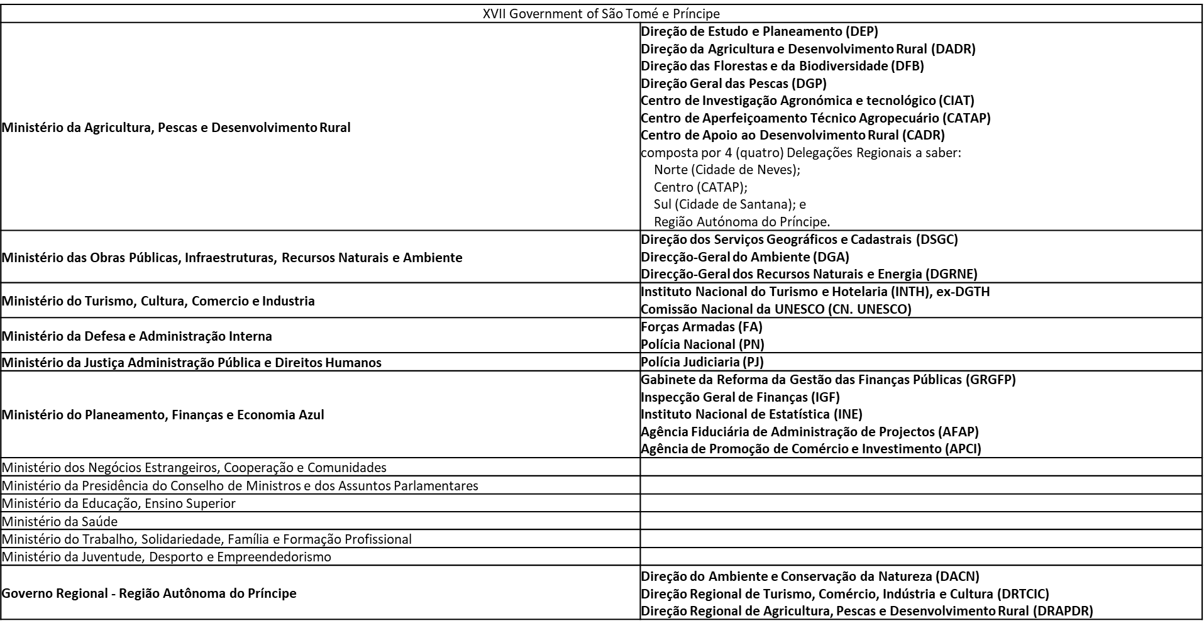

Fig. 2 – Composition of the Government of the Autonomous Region of Principe

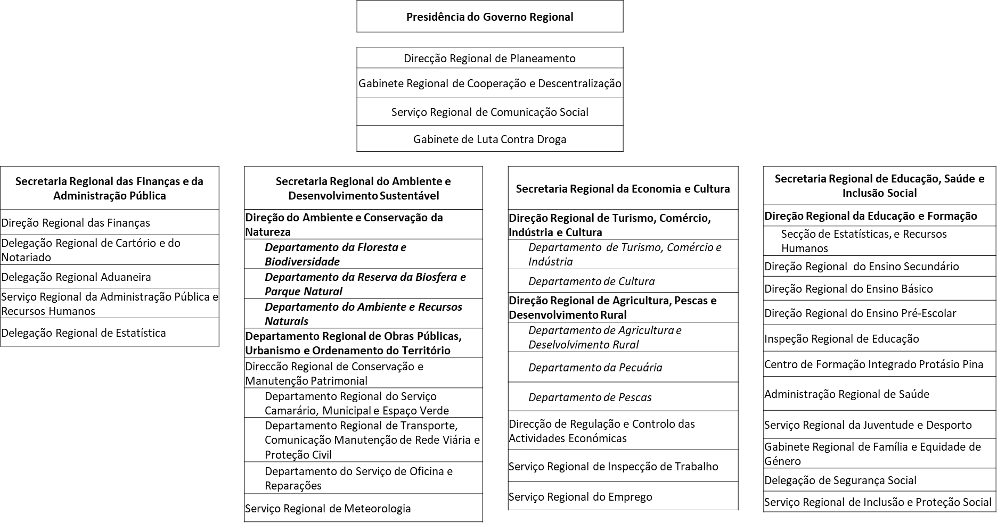

2. Project Stakeholders, Description and Project Role
The project will actively coordinate with relevant Government Ministries, Departments and Agencies and other development partners as well as NGOs and research institutions to facilitate synergies and avoid duplication of efforts. The goal of this Stakeholder Engagement Plan is to involve all stakeholders of the project, as early as possible in the implementation process and throughout project duration to ensure that, their views and concerns are made known and taken into account. The plan will help the project in implementing effective communication channels and working relationships. The Executing Agency will continue to hold consultations throughout project implementation as deemed necessary. This section provides a summary of the engagement of the major stakeholders. The Stakeholder Engagement Plan will be implemented in conjunction with the gender action plan included in the PRODOC Annexes, the Livelihood Action Plan and a Human Rights Action Plan that will be developed before launching the activities, and the process framework for restriction of access to natural resources.
Stakeholder  Intervenient | Summary Description | Project Role
National Central Government & Government of the Autonomous Region of Principe
MOPIRNA – Ministry of Infrastructure, Public Works, Natural Resources and Environment  General Directorate for Environment  Direcção-Geral do Ambiente (DGA). | Government body responsible for designing and implementing policies related to the environment, conservation / preservation of ecosystems and the longevity of species and life on Earth. The specific attributions are: to guarantee the effective application of laws and other environmental policy instruments, through evaluation and monitoring; collaborate in the elaboration of an integrated environmental policy, ensuring multisector coordination; create and coordinate the National Environmental Information System and produce statistical indicators; accreditation of companies in the environmental area; collaborate in the definition of a waste management policy; encourage the development of new technologies in the environmental area; coordinate the integration of environmental issues in international relations; to propose the appointment of Focal Points for certain environmental areas and to coordinate their actions. | - Implementing Partner – in charge of overall project implementation  - Exchange of information and best practices; participation in decision-making  - Project design and adaptive management, participatory elaboration of annual activities, participation in monitoring and evaluation (overall project implementation) / Project Board  - Data collection for research purposes  - Exchange of information and best practices  - Member of advisory body (overall project implementation)  - Beneficiaries and providers of training / capacity building activities  - Project ongoing support for biodiversity & sustainable land-use mainstreaming into activities; dialogue, outreach and consultation  - National Environmental Law Enforcement Platform  - National Sustainable Charcoal Platform  - Participatory appraisals of community needs (livelihoods, PAs, HCVs, law enforcement)  - Inception Workshop
 | 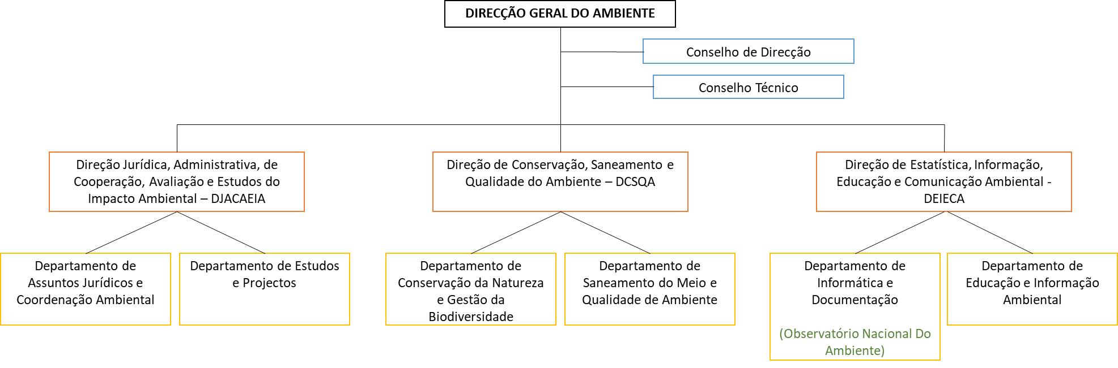
MAPDR – Ministry of Agriculture, Fisheries and Rural Development  Directorate for Forests and Biodiversity  Direção das Florestas e da Biodiversidade (DFB). | Government body responsible for designing and implementing policies approved for the area of forest promotion and biodiversity, inspection, statistics and promotion of the forest products industry (timber and non-timber product), as well as coordinating the activities of the Obô São Tomé Natural Park (PNOST). | - Lead Agency or Responsible Party to be designated by DGA – in charge of delivery of several output packages; dialogue, outreach and consultation; participation in decision-making  - Project design and adaptive management, participatory elaboration of annual activities, participation in monitoring and evaluation (overall project implementation) / Project Board  - Participation in high-level advocacy meetings  - Data collection for research purposes  - Exchange of information and best practices  - Member of advisory body  - Beneficiaries and providers of training / capacity building activities  - Project ongoing support for biodiversity & sustainable land-use mainstreaming into activities  - National Environmental Law Enforcement Platform  - National Sustainable Charcoal Platform  - Participatory appraisals of community needs (livelihoods, PAs, HCVs, reforestation)  - Inception Workshop
 | 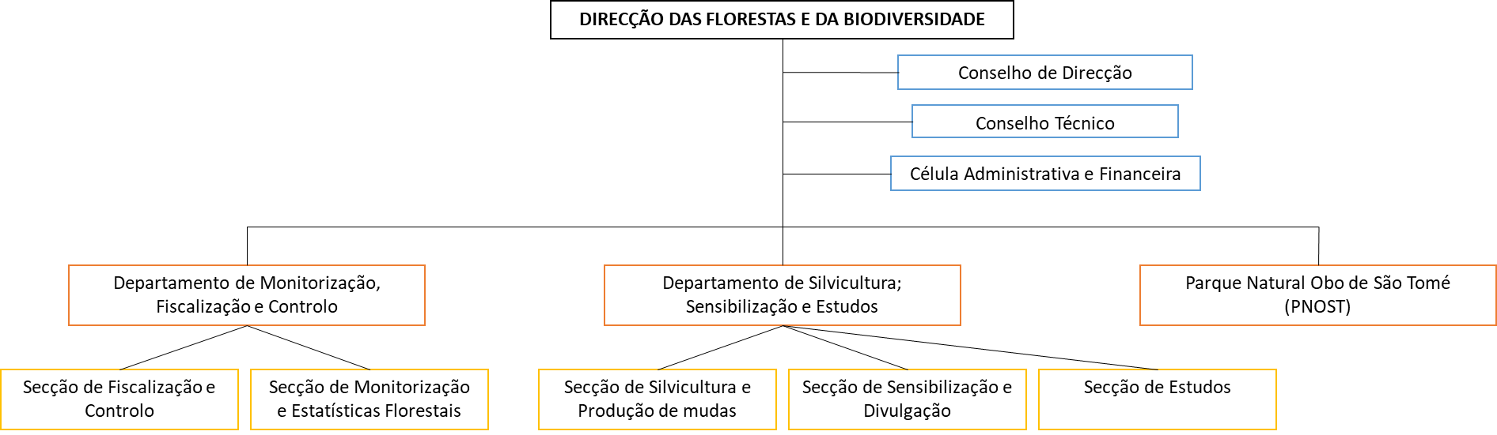
Regional Secretariat for Environment and Sustainable Development of Principe  Secretaria Regional do Ambiente e Desenvolvimento Sustentável  Directorate for Environment and Nature Conservation  Direção do Ambiente e Conservação da Natureza (DACN) | Regional delegation of the national General Directorate for Environment and the national Directorate for Forests and Biodiversity, yet under the Regional Autonomous Government of Principe. Responsible for designing, implementing, coordinating, monitoring and evaluating the policy defined and approved by the government for the areas of environment, nature and biosphere conservation, public works, natural resources, solid waste and urban development.  It entails three Departments: Forest & Biodiversity Department; Biosphere Reserve & Natural Park Department; Environment & Natural Resources Department | - As above.
MOPIRNA  Directorate of Geographical and Cadastral Services  Direção dos Serviços Geográficos e Cadastrais (DSGC). | Government body responsible for implementing policies in the fields of Cartography, Geodesy and Cadastre, including national spatial planning. In particular: to carry out topographical surveys as well as the elaboration of geographical and thematic maps, carry out calculations, projections and drawings of all the areas surveyed and which should serve as a basis for the elaboration of spatial planning and urban planning instruments; to ensure the application of the policy of land occupation, use and transformation, participating in the control and supervision, for the best protection of the environment; to participate in the elaboration of standards, technical-economic indices and working procedures for spatial planning; to participate in the elaboration and proposal of projects for the development of the urban system. | - Collaboration on specific action of Component 1 & member of advisory body; dialogue, outreach and consultation; participation in decision-making (Land Use / PNOT)  - Project design and adaptive management, participatory elaboration of annual activities, participation in monitoring and evaluation (C1 – PNOT)  - Participation in high-level advocacy meetings  - Beneficiaries and providers of training / capacity building activities  - Project ongoing support for biodiversity & sustainable land-use mainstreaming into activities; dialogue, outreach and consultation / awareness raising  - National Environmental Law Enforcement Platform  - Inception Workshop
 | 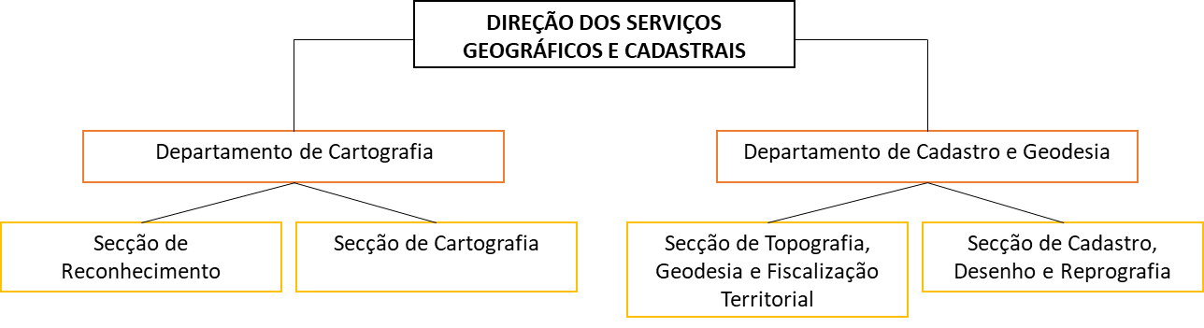
Regional Secretariat for Environment and Sustainable Development of Principe  Regional Department for Public Works, Urbanism and Spatial Planning  Departamento Regional de Obras Públicas, Urbanismo e Ordenamento do Território | This is the regional delegation of the national Directorate of Geographical and Cadastral Services, yet under the Regional Autonomous Government of Principe. | - As above
Regional Secretariat for Economy and Culture of Principe / Secretaria Regional da Economia e Cultura  Regional Directorate of Tourism, Commerce, Industry and Culture  Direção Regional de Turismo, Comércio, Indústria e Cultura | Regional delegation of Ministry of Tourism, Culture, Commerce and Industry | - As above
Regional Secretariat for Economy and Culture of Principe  Regional Directorate for Agriculture, Fisheries and Rural Development  Direção Regional de Agricultura, Pescas e Desenvolvimento Rural | Regional delegation of Directorate of Agriculture and Rural Development (including CADR) & Directorate for Fisheries and Fishery Resources | - As above
MAPDR  Department of Land Affairs  Departamento de Assuntos Fundiários (DAFu) | Department from the Directorate of Agriculture and Rural Development (see below), responsible for carrying out rural registration, land management and reorganization, and the supervision of land use. | - As above
National Platform for Forest and Landscape Restoration of Sao Tome and Principe  Plataforma Nacional de Restauração Florestal e Paisagística de São Tomé e Príncipe (PNRFP-STP) | As part of the Landscape Restoration for Ecosystem Functionality and Climate Change Mitigation GEF6-funded FAO-led project, the PNRFP-STP was created and brings together all the relevant actors in the integrated management of forest resources, landscape restoration and promotion of more sustainable land use systems.  The main mission of the PNRFP-STP is to guide and support Forest and Landscape Restoration policies and strategies, as well as studies and other actions related to forest ecosystems. To this end, the following competencies and responsibilities are:  - To serve as a forum for discussion and promotion of debate on issues related to Forest and Landscape Restoration in São Tomé and Príncipe;  - Contribute to the dissemination of communication on Forest and Landscape Restoration and ongoing initiatives;  - Promote coordination and promote synergies between initiatives with an impact on Forest and Landscape Restoration and on the sustainable management of the country's forest ecosystems;  - Coordinate all actions/activities of planning and development of forest and landscape restoration policies in São Tomé and Príncipe;  - Play a leading role in identifying the most appropriate entry points for policy change, including strategic plans, laws, regulations, incentives and intersectoral integration, in formulating measures and changes for policy improvement and in designing concrete policies, regulations and incentives to be incorporated into the national policy framework through an agreed roadmap;  - Collaborate in the development of studies in the field of Forest and Landscape Restoration and in the implementation of other actions related to ecosystem services in forests, and proceed with their validation;  - Guide the Government of São Tomé and Príncipe on new initiatives in the field of forest conservation, management and restoration in the country. | - Collaboration on specific action of Component 3 (reforestation)  - Could host the proposed National Platform on Sustainable Charcoal  - Project design and adaptive management, participatory elaboration of annual activities, participation in monitoring and evaluation (reforestation activities)  - Exchange of information and best practices  - Beneficiaries of training / capacity building activities  - Project ongoing support for biodiversity & sustainable land-use mainstreaming into activities; dialogue, outreach and consultation / awareness raising  - Inception Workshop
Implementation Cell of the São Tomé and Príncipe Spatial & Land-Use Plan  Célula de Execução do Plano Nacional de Ordenamento do Território de São Tomé e Príncipe | At the beginning of 2016, the African Development Bank granted a loan for the project entitled São Tomé and Príncipe Land-Use and Spatial Planning (PNOT), leaving the Ministry of Infrastructure, Environment and Natural Resources as the entity responsible for their implementation, having created its own structure for this purpose, called the Implementation Cell of the PNOT.  Mainly based on the observation that many stakeholders, not coordinated, intervene in issues of spatial planning, the PNOT proposes the creation of an authority, bringing together the main stakeholders, in particular the Directorate of Geographic and Cadastral Services and the Department of Land Affairs, which may later absorb other sectors : 'Create an institutional structure (similar to the PNOT Implementation Cell), properly equipped with human and material resources and, if necessary, supported by consultants with international experience, to manage the implementation of the PNOT and ensure the training of local staff'. | - Projected to continue in some form, will oversee the application of the PNOT land management plan, will benefit from or lead land use assessment by the project, and will host the project’s National Environment Mainstreaming Officer  - Inception Workshop
National Committee on Climate Change  Comité Nacional para as Mudanças Climáticas (CNMC) | Body for consultation, training, awareness-raising and facilitation in the design, financing, implementation, validation and monitoring of the different activities (programmes and projects) to be developed within the framework of the implementation of the United Nations Framework Convention on Climate Change and its additional legal instruments in São Tomé and Príncipe.  The CNMC should also ensure coherence between programmes/projects and national climate change priorities at the level of adaptation and mitigation.  The CNMC assumes the following responsibilities and attributions:  - Provide advice and technical assistance to the Government in making decisions on matters related to Climate Change;  - Promote public awareness and dissemination programs on Climate Change;  - Ensure the centralisation, capitalisation and dissemination of information on Climate Change;  - Provide technical and scientific support to the decisions and orientation of project/programme actions and regular monitoring of their implementation;  - Assume the role of steering committee or technical monitoring of any and all projects related to Climate Change that is implemented in the RDSTP, in order to avoid duplication of efforts;  - Validation of Climate Change projects before they are submitted to the international community for funding;  - Issue opinions on certain specific issues. | - Exchange of information and best practices  - Project ongoing support for biodiversity & sustainable land-use mainstreaming into activities; dialogue, outreach and consultation  - National Sustainable Charcoal Platform  - Inception Workshop
Ministry of Planning, Finance and Blue Economy  Trade and Investment Promotion Agency  Agência de Promoção de Comércio e Investimento (APCI). | Promotion agency, acting as a link between national and foreign investors and state institutions, to facilitate access to investment. | - Collaboration on specific action of Component 1 (PNOT) & 2 (innovative management/partnership models in PAs and HCV areas)  - Beneficiaries of training / capacity building activities  - Project ongoing support for biodiversity & sustainable land-use mainstreaming into activities; dialogue, outreach and consultation / awareness raising  - Inception Workshop
MOPIRNA  General-Directorate for Natural Resources and Energy  Direção-geral dos Recursos Naturais e Energia (DGRNE) | Government body responsible for designing and implementing policies related to Natural Resources and Energy. In particular: to elaborate studies and research on the characteristics and conditions of the country's natural resources, its territorial distribution and the level of exploitation; to analyse studies and investigations recommended by general guidelines on the use of the natural resources; to ensure the effective implementation of policy, laws and other policy instruments in the natural resources and energy sector; to ensure integrated management of natural and energy resources. | - Beneficiaries and providers of training / capacity building activities  - Member of advisory body, in particular for Component 3  - Project ongoing support for biodiversity & sustainable land-use mainstreaming into activities / strategies / planning; dialogue and outreach  - National Environmental Law Enforcement Platform  - National Sustainable Charcoal Platform  - Inception Workshop
 | 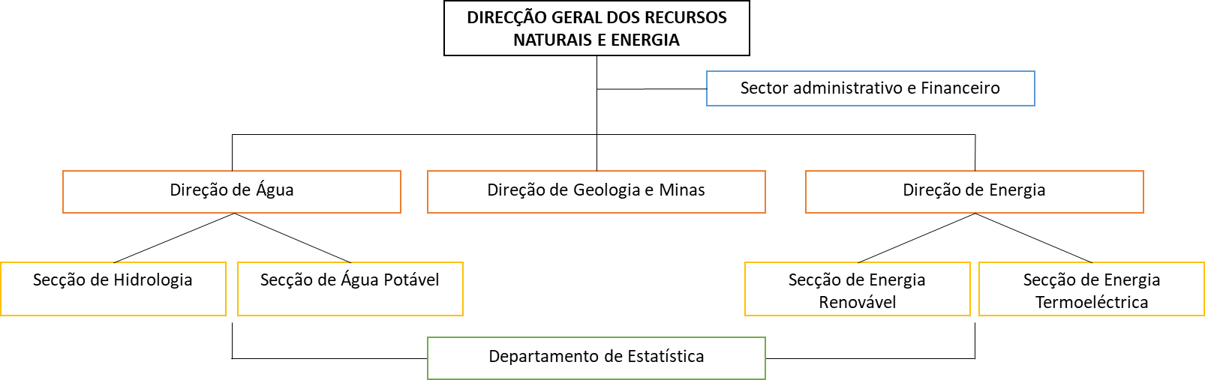
MAPDR  Directorate of Agriculture and Rural Development  Direção da Agricultura e Desenvolvimento Rural (DADR) | Government body responsible for designing and formulating policies in the fields of agricultural production, in particular export crops, horticultural and food crops, crop and soil protection, their conservation, and the promotion of agro-industrial activities, food security, as well as support for rural development, associativism and cooperativism. Some of its specific attributions are: to articulate and guide the Regional Delegations in the implementation of the policies approved for the areas of family agricultural production; to technically direct all questions related to the implementation of activities that ensure the efficient and diversified development of agriculture; to organize and technically coordinate all actions leading to the promotion of rural development and the promotion of associativism and sustained cooperativism in the rural world; to carry out rural registration, land management and reorganization, and the supervision of land use and sustainable irrigation. | - As above
 | 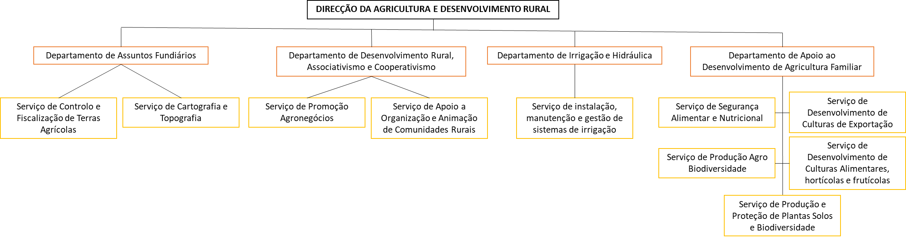
MAPDR  Directorate of Study and Planning  Direção de Estudo e Planeamento (DEP) | Government body responsible for planning, designing and developing the overall policy and strategic axes for agricultural and Food and Nutrition Security, as well as carry out due monitoring and evaluation of these policies within the ministry: coordinate the implementation of the development policies defined by the Ministry; articulate with the Technical Directorates and coordinate the activities of the Regional Delegations; participate in the definition and study of development programmes and projects for the sector; ensure the collection, production, processing and circulation of relevant data for the Ministry; propose actions to improve the process of logistics and adequate and timely procurement; establish mechanisms to monitor and evaluate development programmes and projects of the various services of the Ministry, proving their physical and financial implementation. | - As above
MAPDR  Rural Development Support Centre & Regional Delegations  Centro de Apoio ao Desenvolvimento Rural (CADR)  4 regional delegations:  Norte (Cidade de Neves)  Centro (CATAP)  Sul (Cidade de Santana)  Região do Príncipe | Agencies that articulate their actions with the respective technical directorates (Directorate for Agriculture and Rural Development, Directorate for Forestry and Biodiversity, Directorate for Fisheries, projects, and other institutions), and are accountable to the Directorate for Study and Planning, being responsible for the area of Technical Assistance and Rural Extension. It is the responsibility of the Rural Development Support centre: coordinate and execute the activities of technical assistance and rural extension throughout the national territory; draw up the annual plan for technical assistance and rural extension to producers and fishermen, in close collaboration with the technical directorates; participate and / or collaborate in studies or services for rural areas; follow up the activities of non-governmental organizations and other institutions that develop actions in rural areas; collaborate with research and training institutions in the field of agricultural extension and vulgarization; develop jointly with the department of associativism and cooperativism awareness activities on various topics that affect the rural areas; report to the ministry any possible problems or conflicts on agricultural, forestry and land-use in the area of jurisdiction; elaborate annually and submit to the ministry the needs for agricultural inputs, and proceed with their marketing. | - As above
MAPDR  Agricultural Technical Improvement Centre  Centre Centro de Aperfeiçoamento Técnico Agropecuário (CATAP) | Institution with administrative and financial autonomy focused on the capacity building of technical staff of the MADR, technical and professional training and capacity building of producers, promotion of courses and actions of vulgarization for small farmers, holding lectures and seminars on specific topics. | - As above
MAPDR  Agricultural and Technological Research Centre  Centro de Investigação Agronómica e Tecnológico (CIAT) | Institution with administrative and financial autonomy dedicated to research in the agronomic field and dissemination of results, with a view to increase productivity and diversification of agro-forestry-pastoral systems. Also, this institution is dedicated to carry out applied research in the area of Food Safety, Nutrition and Quality of Life in close collaboration with the Directorate for Studies and Planning and the Agricultural Development Directorate. | - As above
MAPDR  Directorate for Fisheries and Fishery Resources Direcção das Pescas e Recursos Haliêuticos (DPRH). | Government body responsible, amongst other activities, for the management of artisanal fisheries projects, registration of artisanal or industrial fishermen, and surveillance of fisheries activities in the EEZ of STP. | - Will be consulted in preliminary discussions about how new legal frameworks must be linked to future MPAs (Marine Protected Areas)  - Inception Workshop
 | 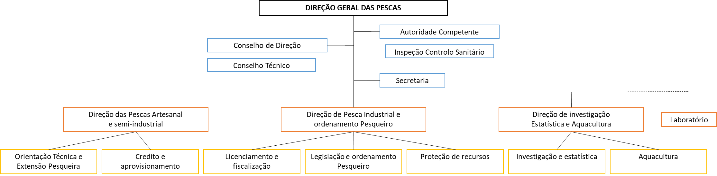
Ministry of Tourism, Culture, Commerce and Industry  General Directorate for Tourism and Hospitality  Direção-geral do Turismo e Hotelaria (DGTH). | Government body responsible for the design, implementation and evaluation of policies and overall objectives set by the Government in the fields of tourism and hospitality and regulation, monitoring and promotion of tourism activities. In particular: contribute to the definition of tourism policy and respective implementation and evaluation; promote the improvement of the quality of tourism services; collaborate in the preservation and enhancement of tourism resources, promote and guide their convenient use; contribute to the enrichment and diversification of the national tourism product; encourage and promote the implementation of activities of interest to the tourism sector; to ensure the country's tourism promotion; to support the government in negotiations and decisions, in international bodies, that are related to tourism policy; to ensure competitiveness and fair competition in tourism activities; to promote, with institutions and educational establishments, partnerships with a view to training and capacitating people in the tourism, hotel and restaurant sector. | - Collaboration on specific action of Component 2 (tourism practices, tourism revenue, tourism in PAs, HVC concessions, etc.)  - Member of advisory body  - Beneficiaries and providers of training / capacity building activities  - Project ongoing support for biodiversity & sustainable land-use mainstreaming into activities / strategies / planning; dialogue and outreach  - National Environmental Law Enforcement Platform  - Inception Workshop
 | 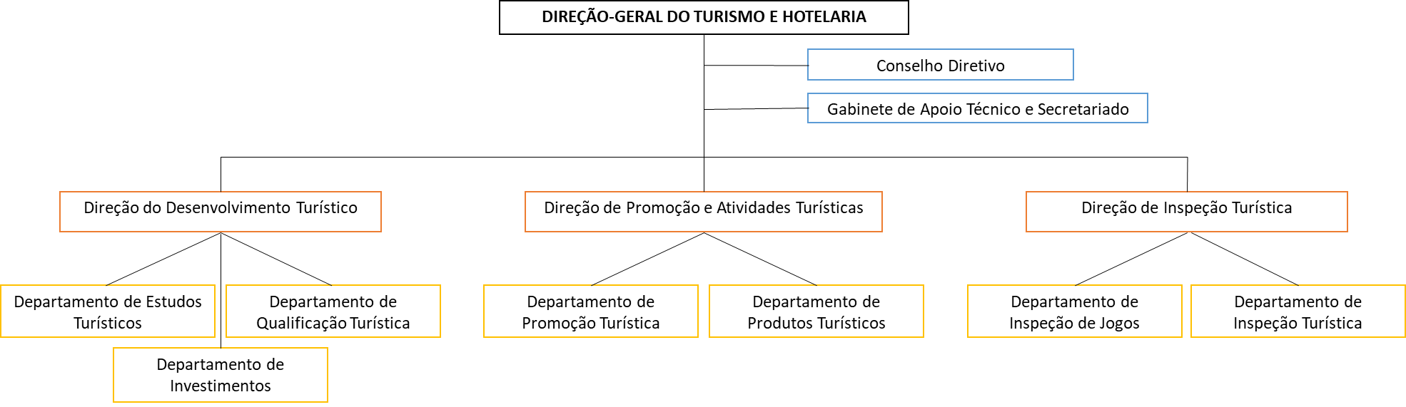
Ministry of Defence and Internal Affairs  Military Forces & National Police  Forças Armadas & Polícia Nacional | Government body responsible for, among other, ensure and supervise law enforcement, through the administration of the Military Forces, the Security Forces and Services and affiliated institutions. | - Collaboration on specific action of Component 1 (National Environmental Law Enforcement Platform, enforcement system, etc.); dialogue, and outreach  - Beneficiaries of training / capacity building activities  - Inception Workshop
Ministry of Justice, Public Administration and Human Rights | Government body responsible for leading, implementing and controlling the policies in the areas of Justice, Public Administration and Human Rights. | - Collaboration on specific action of Component 1 (Natural Resources Law Enforcement, land conflict resolution); dialogue, outreach and consultation  - National Environmental Law Enforcement Platform  - National Sustainable Charcoal Platform  - Inception Workshop
Multilateral Agencies
UNDP | GEF Implementing Agency  Sao Tomé and Principe office of the United Nations Development Programme | - GEF Implementing Agency – oversight and in that role on Project Board  - Project design and technical advisory services under oversight role  - Providing implementation support upon request from Government/Implementation Parties – procurement, payments, HR
IFAD | GEF Implementing Agency  Sao Tomé and Principe office of the International Fund for Agricultural Development | - Exchange of information and best practices  - Collaboration on specific action of Component 2 (IFAD/EU-HCVs) & 3 (DFB/FAO/TRI – reforestation / participation in decision-making)  - Project ongoing support for biodiversity & sustainable land-use mainstreaming into activities; dialogue and consultation  - Inception Workshop
FAO | GEF Implementing Agency  Sao Tomé and Principe office of the Food and Agriculture Organizaton of the United Nations
AfDB | GEF Implementing Agency  Sao Tomé and Principe office of the African Development Bank
WBG | GEF Implementing Agency  Sao Tomé and Principe office of the The World Bank Group
EUD | Delegation of the European Union to Gabon, Sao Tomé-et-Principe and CEEAC | - As above
IUCN | GEF Implementing Agency  Sao Tomé and Principe office of the International Union for Conservation of Nature | - Exchange of information and best practices  - Experience sharing and collaboration on specific action of Component 2 (PAs, HCVs)
Non-Governmental Organization
BirdLife International | Oldest international conservation organisation and the largest global partnership of conservation organisations, BirdLife strives to conserve birds, their habitats and global biodiversity, working with people towards sustainability in the use of natural resources. Together there are 115 BirdLife Partners worldwide – one per country or territory – and growing.  BirdLife is widely recognised as the world leader in bird conservation and is the official IUCN Red List authority on birds. It provides data on population estimates, trends and conservation status of all (c. 11,000) bird species in the world. BirdLife’s Important Bird and Biodiversity Programme has identified around 13,000 global and regional sites in terrestrial, freshwater and marine ecosystems all over the world, making this the largest global network of sites of significance for biodiversity. Rigorous science informed by practical feedback from projects on the ground in important sites and habitats enables BirdLife to implement successful conservation programmes for birds and all nature. BirdLife actions are providing both practical and sustainable solutions significantly benefiting nature and people.  BirdLife International has been working in STP since 2006, initially studying the ecology and conservation needs of the four critically endangered bird species, developing action plans for them and undertaking some actions to implement these action plans. In 2017, BirdLife signed a Memorandum of Understanding, through the Ministry of Agriculture and Regional Government of Principe, for co-Management of the Conservation Areas. In 2018, the European Union (EU) 4-year (2018-21) project funded through the Ecosystèmes des Forets d'Afrique Centrale (ECOFAC VI) grant, was launched. BirdLife is coordinating the action (supporting several organizations) and has secured funding to start with key conservation activities on the ground. | - Responsible Party designated by UNDP – in charge of delivery of several output packages; participation in decision-making  - Project design and adaptive management, participatory elaboration of annual activities, participation in monitoring and evaluation (overall project implementation) / Project Board  - Participation in high-level advocacy meetings  - Data collection for research purposes  - Member of advisory body (overall project implementation)  - Exchange of information and best practices  - Providers of training / capacity building activities  - National Environmental Law Enforcement Platform  - National Sustainable Charcoal Platform  - Participatory appraisals of community needs (livelihoods, PAs, HCVs, reforestation, law enforcement)  - Inception Workshop
Fundação Principe | Active only on Príncipe island, the Príncipe Foundation (formerly the Príncipe Trust Foundation) is a non-profit non-governmental organisation that, since 2015, has been working in partnership with regional entities for the conservation and protection of the ecosystems of Príncipe Island, enhancing the economic and social development of local communities. Today, about 40 employees, who are trained for the implementation of marine and terrestrial conservation projects, together with a network of national and international partners (Fauna and Flora International, BirdLife International), who have contributed greatly to the exponential growth of the organisation and, above all, to the capacity of the team that currently coordinates and manages projects independently and with recognized success. | - Potential sub-grantees (of BirdLife International) under Component 2 & 3  - Beneficiaries and co-providers of training / capacity building activities  - Dialogue, outreach and consultation  - National Sustainable Charcoal Platform  - Data collection for research purposes  - Participatory appraisals of community needs (livelihoods, PAs, HCVs, etc.)  - Inception Workshop
Oikos – Cooperação e Desenvolvimento | Founded on February 23rd 1988, in Portugal, NGO specialized in Development, including Education, Social Mobilization and Public Influence. Oikos opened an office in São Tomé and Príncipe in 2015.  Currently implementation partner of the ECOFAC VI project and the Blue Action Fund, Oikos has carried out projects such as:  - Strengthening civil society and relevant stakeholders to participate in the institutional construction of biodiversity conservation policies and benefit sharing in São Tomé and Príncipe, and  - Sustainable co-management of fisheries in the south of São Tomé Island.
Federação de Organizações Não Governamentais em São Tomé e Príncipe (FONG-STP) | Created in April 2001, growing (currently 98 members), home to national and international NGOs, FONG-STP has the following main objectives:  - To represent the various Non-Governmental Organizations (NGOs) operating in São Tomé and Príncipe;  - To promote greater cooperation and coordination between National and Foreign NGOs and the Government of São Tomé and Príncipe, as well as with Donors and other individuals and/or institutions involved in Humanitarian Assistance and Development processes in the country;  - Promote and mediate the regional and international cooperation of NGOs as well as develop communication networks for better insertion and solidarity of its members;  - Promote the strengthening of National NGOs in order to facilitate their long-term sustainability. | - Collaboration on specific action of Component 1  - Beneficiaries and co-providers of training / capacity building activities; dialogue and outreach  - Inception Workshop
Platform for Responsible and Sustainable Tourism  Plataforma do Turismo Responsável e Sustentável (PTRS) | Based in the city of São Tomé, the PTRS aims to promote responsible and sustainable tourism, in order to protect ecosystems and biodiversity, and preserve cultural and social heritage, through tourist services of excellence.  Created under the GEF5-funded IFAD-led project, the platform brings together tourism operators, cooperatives, civil society, individuals and local associations. In 2018, Mucumbli, Cocoa Residence, HBD, Roça Abade / Príncipe Tours, ABS, AGSTP, Associação Monte Pico, Alisei, FENAPA STP, Zatona Adil, Navetur, Mistral Voyages, STP Tours, Eventur, Pestana Group, Monte Forte, Yam Beach, Mionga, CECAFEB, CECAQ-11, CECAB, Food Crops Sector, CEPIBA, LOBELIA, NGO Marapa / Jalé Ecolodge, Qua-Tela, Hull Blyth, ISLAND TOURS and ICEA were members of the Platform.  The values shared by the members are defined by 20 pillars described in the 'Sustainability Charter'. | - Collaboration on specific action of Component 2 (tourism practices, tourism revenue, tourism in PAs, HVC concessions, etc.)  - Beneficiaries of training / capacity building activities  - Dialogue and outreach  - National Environmental Law Enforcement Platform  - Inception Workshop
We Are Changing Together (WACT) | Portuguese NGO based in São Tomé e Príncipe since 2009.  In 2016, Bô Energia project was created by WACT: (i) raising public awareness of the environmental risks inherent to the use of fossil fuels, (ii) the reuse of flammable waste residues and (iii) the production of briquettes as a more sustainable and alternative source of energy to coal.  This transition presupposes the construction of a production centre and will take place without economic and social costs, through the reconversion and involvement of the current charcoal producers in the production and sale of briquettes. | - Collaboration on specific action of Component 3  - Beneficiaries and co-providers of training / capacity building activities  - Dialogue and consultation  - National Sustainable Charcoal Platform  - Inception Workshop
Gulf of Guinea Biodiversity Center  Centro de Biodiversidade do Golf de Guiné | In order to facilitate and promote comprehensive / coordinated research and education programmes on the unique diversity of plants and animals on the oceanic islands of Sao Tome, Principe and Annobón, a group of biologists and educators is preparing to establish the Gulf of Guinea Biodiversity Centre.  The Centre will be based in Sao Tome with delegation in Príncipe and Annobón.  The Gulf of Guinea Biodiversity Centre will:  - Have a research centre with rooms, library and laboratory for scientists, educators and students;  - Provide teaching spaces for nationals and tourists, including an interpretative museum, classrooms and auditorium;  - Create opportunities for inhabitants to develop ecotourism on the islands;  - Act as a logistic platform for research projects;  - Be a repository of information on flora, fauna and conservation on these islands.  The Centre shall be registered in STP by the end of 2020. | - Providers of training / capacity building activities  - Collaboration on specific action of Component 2 (scientific / research support), dialogue and consultation  - Data collection for research purposes
MAR Ambiente Pesca Artesanal (MARAPA) | Created in 1999, by fisheries technicians, marine biologists and development agents, MARAPA is recognised for its knowledge on marine environment, fishery resources and artisanal fisheries.  Its actions aimed at the protection of marine and coastal habitats, the co-management of fishery resources and support to actors in the fisheries sector.  The Tatô Programme, dedicated to sea turtles, and Operation Tunhã, an initiative for monitoring and follow-up of cetaceans, are noteworthy. | - Exchange of information and best practices (Law Enforcement experience)  - Consultations on basic legal framework layout linkages to future MPAs  - Inception Workshop
Associação Programa Tatô (APT) | In 2003, the NGO MARAPA created the Tatô Program, in order to protect sea turtles. For years, MARAPA had the support of several national and international organizations. Over the years, the Tatô Programme team has grown, and, in 2018, the coordination team created an international NGO, the APT, thus maintaining the name, already known by all communities, national authorities, civil society, as well as internationally.  Considering the challenges facing the conservation of sea turtles, the APT has an integrated approach to improve the protection and sustainable management of the main habitats of sea turtles (nesting beaches and feeding areas), through the involvement of national stakeholders, through capacity building, through the development of livelihoods alternative and increasing the awareness of coastal communities.  On the island of São Tomé, monitoring activities are led every year on 23 km of beach. 21 beaches are monitored to the north, east and south of the island, as well as on the beaches of Ilhéu das Rolas. In addition to the main spawning beaches, the feeding and resting areas of sea turtles off the island of São Tomé are also monitored.
Apoio ao Desenvolvimento de Iniciativas Locais (ZATONA ADIL) | Local association with weak resources and low capacity - Community awareness and mobilization for the environment. | - Collaboration on specific action of Component 2  - Beneficiaries of training / capacity building activities  - Dialogue, outreach and consultation / awareness raising  - Inception Workshop
Associação Monte Pico | Local association with weak resources and low capacity - Headquartered in Monte Café and operating mainly in the São Tomé Obô Natural Park and its Buffer Zone. Assistance to scientific research, field guides and awareness-raising activities.
Ação para o Desenvolvimento Agropecuário e Proteção Ambiental (ADAPPA) | Local association with weak resources and low capacity - Fighting poverty, promoting food and nutrition security, and ensuring sustainable development.
ALISEI | (Italian NGO) Promote knowledge, studies and initiatives to combat poverty in underdeveloped countries. In partnership with MARAPA, manages Jalé Ecolodge. | - Collaboration on specific action of Component 2 (PAs – link with CEPF projects)  - Beneficiaries of training / capacity building activities  - Dialogue, outreach and consultation / awareness raising  - Inception Workshop
TESE - Associação para o desenvolvimento | (Portuguese NGO) Specialized in waste management in São Tomé and Príncipe. TESE supports, among other initiatives, the Waste Processing Centre (CPR) in São Tomé, near Santa Casa da Misericórdia. | - Collaboration on specific action of Component 3 (waste management)  - Exchange of information and best practices  - Inception Workshop
Quá-Téla & Federação Nacional dos Pequenos Agricultores (FENAPA) | Local association with weak resources and low capacity - Valorisation of national products (agri-businesses). | - Beneficiaries of training / capacity building activities  - Dialogue, outreach and consultation / awareness raising
Community Based Organisations & Groups
Local communities | In São Tomé, the target communities may include those considered to be important production hotspots for charcoal (Praia das Conchas, Plancas 1&2, Ribeira Funda, Ponta Figa), as well as the other urban centers where resale is centralized (Neves, Guadalupe and the capital São Tomé). Porto Alegre in the south will also be targeted, as it is known to be an important region for coconut harvesting, with also high consumption rates for charcoal. In Príncipe, the project will target São Joaquim, Gaspar and Azeitona, all known to be important charcoal production centers.  However, all communities surrounding PAs or located in forested areas are susceptible to be involved in project activities (Natural Resources Law Enforcement). | - Beneficiaries (low-value grants for sustainable livelihoods and sustainable charcoal initiatives, community-based surveillance, planting of fast-growing charcoal tree species)  - Beneficiaries of training / capacity building activities  - Project ongoing support for biodiversity & sustainable land-use mainstreaming; dialogue, outreach and consultation / awareness raising  - National Environmental Law Enforcement Platform & National Sustainable Charcoal Platform (community / charcoal makers / logger representatives)  - Participatory appraisals of community needs  - Inception Workshop (representatives)  - (+) potential PPP Partner (innovative management/partnership models in PAs and HCV areas)
Land owners
Charcoal makers
Loggers
Academia
Ministry of Education and Higher Education /  University of São Tomé and Príncipe  Universidade de São Tomé e Príncipe (USTP) | Government body responsible for responsible for designing, implementing, coordinating and evaluating the policies for the sectors of Education and Higher Education, preparing and executing the national policy of education, training and higher education. It is also responsible for the administration and management of schools, development, planning, regulation, evaluation and inspection of the educational system.  USTP is a public institution of higher education in São Tomé and Príncipe. It is the only public university in the country. Converted in 2014 into a university after many years existing as several independent educational institutions. Four university campuses, three of which are only in the capital: three organic institutions and a research and extension centre; (i) Higher Institute of Education and Communication; (ii) Higher Institute of Health Sciences, (iii) Superior Polytechnic Institute, offering, among others, the following courses: Degree in Biology, Degree in Agronomy, Degree in Hotel Management, Degree in Information System and Technology; and (iv) Study Centre for Development - Centre for Agricultural Technical Improvement (CATAP), under the supervision of the Ministry of Agriculture.  Several universities have shown interest in sending master's, doctoral or post-doctoral students, mainly Portuguese universities. | - Collaboration on specific action of Component 1 (internships) & 2 (post-graduate trainings)  - Awareness raising  - Data collection for research purposes  - Inception Workshop
Private Sector - Agribusiness and Agriculture
Valúdo | Created in 2018, Valúdo is a growing Santomean company specialized in transformation of coconuts with organic and fair-trade certifications.  Valúdo out-grower project and the Fair-Trade certification provide growers and harvesters with stable financial benefits in exchange of the supply of coconuts, and so, equally throughout the year. They provide inputs and technical supports to the growers and harvesters in order to improve the productivity of their culture; by combining traditional Santomean practices with modern processes of quality and control. Valúdo is responsible for transport and logistics to reach the out-growers and their production, including the ones who live in remote communities. This service allows for the greatest number possible of out-growers to have a source of income.  Valúdo is supporting more than 300 Santomean coconut harvesters, and process more than 2,880,000 coconuts per year in Favorita processing center. The selected coconuts are first stored in collection areas closed to where they were collected. They are then transported to the processing center where Valúdo produces oil and other coconut products.  The company's objective is to successfully recycle 100% of coconut waste. | - Collaboration on specific action of Component 3 – beneficiary / PPP partner, project design and adaptive management, participatory elaboration of annual activities, participation in monitoring and evaluation (semi-industrial charcoal kilns)  - Beneficiaries and co-providers of training / capacity building activities  - Dialogue and consultation  - National Sustainable Charcoal Platform  - Participatory appraisals of community needs (coconuts)  - Inception Workshop
HBD | Investment group (Mark Shuttleworth) - sustainable eco-tourism project on Principe: currently 3 high-class tourism lodges ‘0-carbon’, Sundy Praia, Bom Bom, Roça Sundy. Large investor on Principe island in tourism, private, philanthropic, HBD works in close collaboration with the Regional Government. HBD has played a major role in the impressive development of Principe Island for the past 8 years, by investing in infrastructures, roads and supporting government-endorsed socio-environmental projects. Pro-active actor for the development of the island's sustainable development agenda. Financing / supporting Fundação Príncipe (NGO initially created to take the lead on the corporate activities of the investment group and gradually becoming independent). Also, behind schemes to resettle communities into forest areas designated by government, bordering the Azeitona forest (northern area of the PNP. Large local and expatriate workforce. 1st producer of coconut on Principe island. | - Collaboration on specific action of Component 2 (PAs, HCVs) & 3 (charcoal / coconuts)  - Beneficiaries and co-providers of training / capacity building activities  - Project ongoing support for biodiversity & sustainable land-use mainstreaming; dialogue, outreach and consultation / awareness raising  - Catalyst / Ally for Biodiversity & PAs finance planning; and to mobilise endowment capital for STP Conservation Trust Fund from private sector and philanthropists  - National Sustainable Charcoal Platform  - Inception Workshop
Export Cooperatives | CECAB (Cooperativa de Exportação de Cacau Biológico), CECAQ-11 (Cooperativa de Exportação de Cacau Convencional), CECAFEB (Cooperativa de Exportação de Café Biológico) and CEPIBA (Cooperativa de Exportação de Pimenta Biológica) are cocoa, pepper and vanilla export cooperatives.  Over the past two decades, the Ministry of Agriculture, with financial support from IFAD and the French Agency for Development, has fostered the creation of 4 export cooperatives and the development of partnerships with European companies working in the field of bio-equitable trade (KAOKA, CaféDirect, GEPA, Hom & Ter, Malongo, SlowFood). By 2015, these cooperatives exported about 50% of cocoa beans national production and 100% of coffee and pepper. Recent studies (2014) show that the economic profitability of cooperative members has more than doubled in ten years for cocoa. Since January 2012, the oldest of the four cooperatives has achieved full managerial and financial autonomy (CECAB). Cocoa remains the country's most exported agricultural production and the largest source of income. | - Beneficiaries of training / capacity building activities  - Awareness raising  - National Environmental Law Enforcement Platform & National Sustainable Charcoal Platform  - Inception Workshop  - (+) potential PPP partner (innovative management/partnership models in PAs and HCV areas)
Agripalma | Concession of 4,917ha in the south of São Tomé Island - palm trees for the production of oil. Approximately 2,100ha of palm trees planted to the South-East / South of the island of São Tome. The factory, being built in Emolve, will start producing oil 2020. On the RSPO route, Agripalma is showing a growing interest in actively participating (financially) in conservation & biodiversity in Sao Tomé. | - As above
Satocao | Plantation of about 275ha (concession of about 2,500ha for a period of 25 years renewable, currently under review with the Government of STP due to important overlaps with the Protected Area - PNOST), and buyer of cocoa gum from small farmers, Satocao exports cocoa in dry gum (purchase on the scale of Sao Tome Island / Dryer in Morro Peixe). | - As above
Diogo Vaz | Producer / Buyer (Diogo Vaz Farm, North-West of São Tomé Island) of cocoa gum and local transformation into chocolate and derived products (processing factory and tasting/restoration centre in the city of São Tome). Diogo Vaz began diversifying its production (essential oils, pepper, etc.) in 2018. | - Beneficiaries of training / capacity building activities  - Awareness raising  - Inception Workshop  - (+) potential PPP partner (innovative management/partnership models in PAs and HCV areas)
Claudio Corallo | Producer of cocoa (Terreiro Velho no Príncipe) and coffee (Nova Moca in São Tomé), and local transformation into chocolate and derived products (processing factory and tasting/visiting centre in the city of São Tome). | - As above
3. Stakeholder Engagement Methods / Means and Rules for Communication
The Project Manager, supported by the Project Management Unit and, if necessary, by the Project Board/Project Steering Committee, will hold responsibility for implementation of the project’s stakeholder engagement plan at the whole-project level (see section 3). The resources required are IT equipment, supplies and staff time; travel support and/or travel to project sites; meeting venue and/or catering for community meetings.
Stakeholder | Engagement Methods | Engagement Means | Rules for communication | Responsibilities
General Directorate for Environment | Project Management Unit meetings, Project Board meetings, e-mails, face-to-face meetings, workshops / platform meetings | Exchange of correspondences, meetings / minutes, memos / briefs, newsletters, brochures, field reports, training courses, design supervision, and any relevant documents for project implementation (Feasibility studies / External consultancy reports)  Data collection templates and procedures  Progress reporting (Interim, annual and final reports; external reports; cofinancier activities reports; etc.) | An internal communication plan will be developed by the PM with PMU/RP support to establish basis of transparent and continuous communication between internal stakeholders who are involved in project implementation at the earliest stage of the project. | PM/PMU/RP  In accordance with the rules for internal communication, meetings and the grievance mechanism for workers (employees and contract labour suppliers)
Directorate for Forests and Biodiversity
Environment and Sustainable Development Regional Secretariat - Directorate for Environment and Conservation of Nature
BirdLife International
United Nations Development Programme (UNDP) | Project Board meetings, e-mails, face-to-face meetings, workshops
Directorate of Geographical and Cadastral Services | E-mails, face-to-face meetings, workshops / platform meetings | Progress reporting  [briefs / newsletters / brochures]  Exchange of correspondences, meetings / minutes, field reports, training courses, design supervision, Feasibility studies / External consultancy reports  Data collection templates and procedures  Official letters | In accordance with administrative procedure requirements | PM/PMU/RP
Environment and Sustainable Development Regional Secretariat - Regional Department for Public Works, Urbanism and Spatial Planning
Department of Land Affairs
Agricultural Technical Improvement Centre
Rural Development Support Centre & Regional Delegations
General-Directorate for Natural Resources and Energy
Directorate of Agriculture and Rural Development
Directorate of Study and Planning
Agricultural and Technological Research Centre
General Directorate for Tourism and Hospitality
Military Forces
National Police
Trade and Investment Promotion Agency | E-mails, face-to-face meetings, workshops |  | In accordance with administrative procedure requirements | PM/PMU/RP
Ministry of Education and Higher Education / USTP
Ministry of Justice, Public Administration and Human Rights
International Fund for Agricultural Development
Food and Agriculture Organization
African Development Bank
the World Bank Group
International Union for Conservation of Nature
Delegation of the European Union to Gabon, Sao Tomé-et-Principe and CEEAC
Valúdo | E-mails, face-to-face meetings, workshops / platform meetings |  | In accordance with administrative procedure requirements | PM/PMU/RP
National Platform for Forest and Landscape Restoration of Sao Tome and Principe | E-mails, workshops / platform meetings | Progress reporting  [briefs / newsletters / brochures]  Project decisions  Data usage decisions | In accordance with PNRPF-STP procedure requirements | PM/PMU/RP
National Committee on Climate Change
Oikos – Cooperação e Desenvolvimento | E-mails, face-to-face meetings, workshops / platform meetings | Progress reporting  [briefs / newsletters / brochures]  Exchange of correspondences, meetings / minutes, field reports, training courses, design supervision  Data collection templates and procedures  Official letters | Through RP – BirdLife International | RP – BirdLife International
Fundação Principe
Local communities | Through face-to-face community meetings, individual interviews and workshops | [briefs / newsletters / brochures]  Consultation meetings – providing information, exchange of documentations and correspondences associated with projects, booklets / posters / brochures | In accordance with the rules for internal communication, and the accepted custom.  Direct communication (and indirect through announcements issued to the public). | PM/PMU (e.g., Community Organizers), including RP teams (e.g., Field officers)
Land owners
Charcoal makers
Loggers
Platform for Responsible and Sustainable Tourism | E-mails, face-to-face meetings, workshops / platform meetings | Progress reporting  [briefs / newsletters / brochures]  Official letters | Communication to be done by persons authorised to communicate. Public communication can be done through national reporting rules | PM/PMU/RP
We Are Changing Together (WACT)
Bo Energia
Gulf of Guinea Biodiversity Center | E-mails, face-to-face meetings, workshops |  |  | PM/PMU/RP
Export Cooperatives | E-mails, face-to-face meetings, workshops / platform meetings |  |  | PM/PMU/RP
HBD
Agripalma
Satocao
Diogo Vaz
Claudio Corallo
HBD | E-mails, face-to-face meetings | Progress reporting  [briefs / newsletters / brochures]  Feasibility studies / External consultancy reports  Official letters |  | PM/PMU/RP
Federação de Organizações Não Governamentais em São Tomé e Príncipe (FONG-STP) | E-mails, face-to-face meetings, workshops | [briefs / newsletters / brochures]  Official letters |  | PM/PMU/RP
Apoio ao Desenvolvimento de Iniciativas Locais (ZATONA ADIL)
Associação Monte Pico
Ação para o Desenvolvimento Agropecuário e Proteção Ambiental (ADAPPA)
MAR Ambiente Pesca Artesanal (MARAPA) | E-mails, face-to-face meetings | [briefs / newsletters / brochures]  Official letters |  | PM/PMU/RP
Associação Programa Tatô

4. Grievance mechanism
At the community level, complaints will be directed to the project manager. If the complaint, depending on its complexity, cannot be solved from the Project Manager, it will be taken up by the Project Management Unit, who will address it at the next PMU meeting or, if necessary, organize an emergency meeting. The answer to the complaint should not exceed more than 60 working days’ time and must be given in written form. Complaints will be addressed whenever they refer to a problem occurring within project areas and during the lifetime of the project. The letter of complaint must be signed by any of the owners or holders of complainant. Complaints from other stakeholders, including partners, will also be directed to the project manager or the Project Management Unit. The UNDP-GEF Project Agency will be promptly informed about complaints submitted to the project manager or the Project Technical Unit and their resolution.
In addition, a specific grievance mechanism will be established for each and every Conservation Agreement that is signed with communities. The details of the grievance mechanism will depend on the nature of the agreement and community dynamics. However, at a minimum the grievance management system under any agreement will track grievances and foster conflict resolution from the point of reporting to the point of redress and finality. A Conservation Agreement grievance mechanism will provide a system for recognising and responding coherently to a complaint through identifying a person responsible for investigating the complaint and coordinating response.
The system will include a methodology for the following:
- Receiving complaints through any of the above channels
- Assessing information needs
- Allocating responsibility for investigation
- Recording the process
- Contacting the complainant
- Determination of the facts
- Agreeing responsibility and action where required
- Informing the complainant
- Dealing with disagreements over response and outcome
- Implementing action
- Researching complainant satisfaction
- Monitoring and evaluating the outcome
5. Monitoring and Reporting
The project will endeavour to make information available to the public to allow stakeholders to get to know and understand both the environmental and social risks and impacts associated with the project, as well as opportunities provided by the project. This will enable them to utilise the project data to make informed decision in areas associated with Biodiversity Conservation and Sustainable Land & Natural Resource Management.
On an ongoing basis, the project will have a routine disclosure and consultation on the project’s environmental and socio-economic performance including grievances and other new emerging issues on the project. The disclosures will be done to all stakeholders’ thorough project briefs, newsletter or annual reporting through brochures. While providing this disclosure, the project will also provide:
An update on the Project achievements and how its contributing to enhancing transparency in reporting for Sustainable Development Goals implementation in the country ;
An overview of the stakeholder engagement process and how affected parties can participate and provide feedback through meeting or other avenues;
Project impacts on development and how the government is using the project data to enhance the livelihoods of the people at the same time conserve the environment and report on Biodiversity Conservation and Sustainable Land & Natural Resource Management.
Monitoring is an integral component of project management as it tracks and assesses progress towards achieving tangible development results associated with the project being implemented. It is an essential management tool which provides an opportunity to know whether results are being achieved as planned, what corrective action are needed to ensure delivery of the intended results and how they are making positive development contributions. This helps to detect problems earlier and coming up with appropriate measures to address them. Therefore, monitoring usually provides data used for analysis and synthesis prior to reporting for decision-making.
Parameters for Reporting and Monitoring

Parameter |  | Monitoring and reporting responsibility | Reporting period
1. | Number of government agencies, civil society organizations, private sector, local communities & user groups, and other stakeholder groups that have been involved in the project implementation phase | PM/PMU with RP support | Annual basis
2. | Number persons (sex disaggregated) that have been involved in project implementation phase | PM/PMU with RP support | Annual basis
3. | Number of engagement (e.g. meeting, workshops, consultations) with stakeholders during the project implementation phase | PM/PMU with RP support | Annual basis
4. | Percentage of stakeholders who rate as satisfactory the level at which their views and concerns are taken into account by the project | UNDP-GEF Agency (external hire consultant) | Midterm and final project evaluation
5. | Grievances handling mechanism – how grievances are received, and results communicated to all stakeholders | PM/PMU with RP support | Annual basis

This monitoring and reporting requirement is important not only to track what is happening with projects, but to provide a basis for actions and adjustments that will be needed to address challenges that may arise, and ensure that a project is meeting its objectives. The reports will also provide a window for stakeholders to better understand project activities during the implementation stage, in support of their more informed participation. To this end, the Project Management Unit and Responsible Parties will also develop user-friendly and accessible systems to make information available to stakeholders on stakeholder engagement during the course of the project, and on project progress, changes and outcomes (e.g., use of social media and local TV / radio).
In addition, wherever feasible, the process of monitoring and reporting will also include “participatory monitoring” by stakeholders. This is an important tool that will enhance both the independence, strength and accuracy of monitoring information. As indicated in the GEF-Policy, local communities and CSOs possess essential knowledge, expertise and capabilities relevant to project interventions. Participatory monitoring, which will be based on gender inclusion and other core principles in the Policy and will be one means to harness this for the benefit of the project and better results. In terms of frequency of preparation of the reports, the GEF-UNDP guidelines will be followed.

6. Timetable of stakeholder engagement during project implementation
 | Timeline | 2020 |  |  |  | 2021 |  |  |  |  |  |  |  | 2022 |  |  |  |  |  |  |  | 2023 |  |  |  |  |  |  |  | 2024 |  |  |  |  |  |  |  | 2025
 | Activities | 3 |  | 4 |  | 1 |  | 2 |  | 3 |  | 4 |  | 1 |  | 2 |  | 3 |  | 4 |  | 1 |  | 2 |  | 3 |  | 4 |  | 1 |  | 2 |  | 3 |  | 4 |  | 1 |  | 2 |  | 3 |  | 4
1 | Inception Workshop
2 | Participatory elaboration of annual activities
3 | Monitoring and evaluation (including participation of ext. stakeholders)
4 | Participation in program balance
5 | Project Board
6 | Midterm and final project evaluation
7 | Participatory appraisals of community needs
8 | Participation in high-level advocacy meetings
9 | Continuous Dialogue, outreach and consultation
10 | Project ongoing support for biodiversity & sustainable land-use mainstreaming into activities
11 | National Environmental Law Enforcement Platform
12 | National Sustainable Charcoal Platform
13 | Training / capacity building activities
14 | Awareness raising
15 | Collaboration on specific action
16 | Data collection for research purposes
17 | Advisory body
18 | Exchange of information and best practices
19 | Project design and adaptive management
20 | Identify/Revision the role of stakeholders in project execution (incl. review of Stakeholders Engagement Plan if needed)
21 | Ensure Stakeholders are engaged in respect to environmental and social issues related to the project, and are informed about actions taken in response to their input
22 | Creating and making available a complaint management system

